**HW1---BUAI 434---Due by Midnight on Friday September 24th**

(This HW cannot be done in group. You should do it alone.)

Use the file named HW1.twbx available on CANVAS for the following exercises. For each Exercise, create a new worksheet in the file HW1.twbx and name it “Exercise X” for exercise number X. There are 4 Exercises. So you should end up with 4 worksheets. Upload on CANVAS:

1- Your final “twbx” file which is renamed as: LASTNAME_FIRSTNAME_HW1.twbx and

2- An MS Word file. Export the Image of each of the Worksheet in the MS Word file. Use Worksheet/Export/Image in Tableau to do that.

**Exercise 1**: Produce the following display.

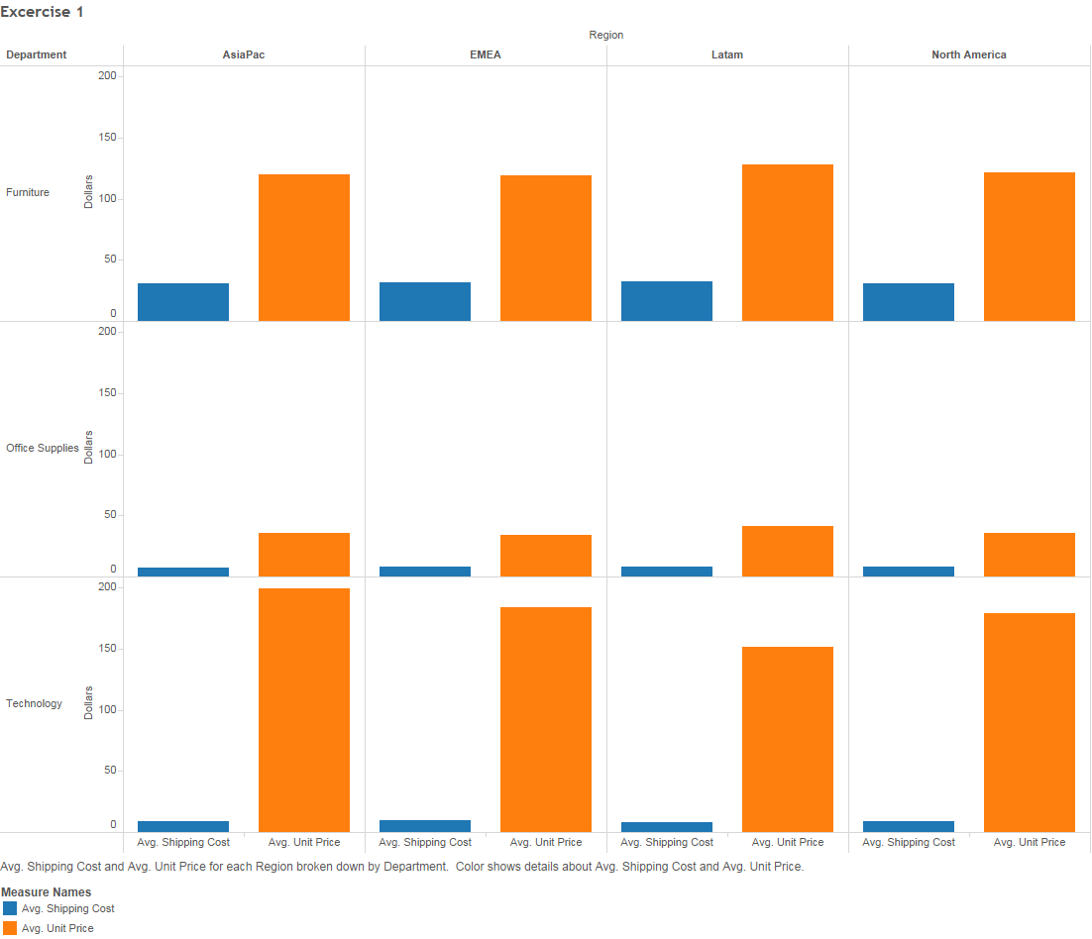

**Exercise 2**: Create a quarter-based custom date value for ship date and name it “Ship Date (Cont. Quarters)”. Then use it to develop the following display:

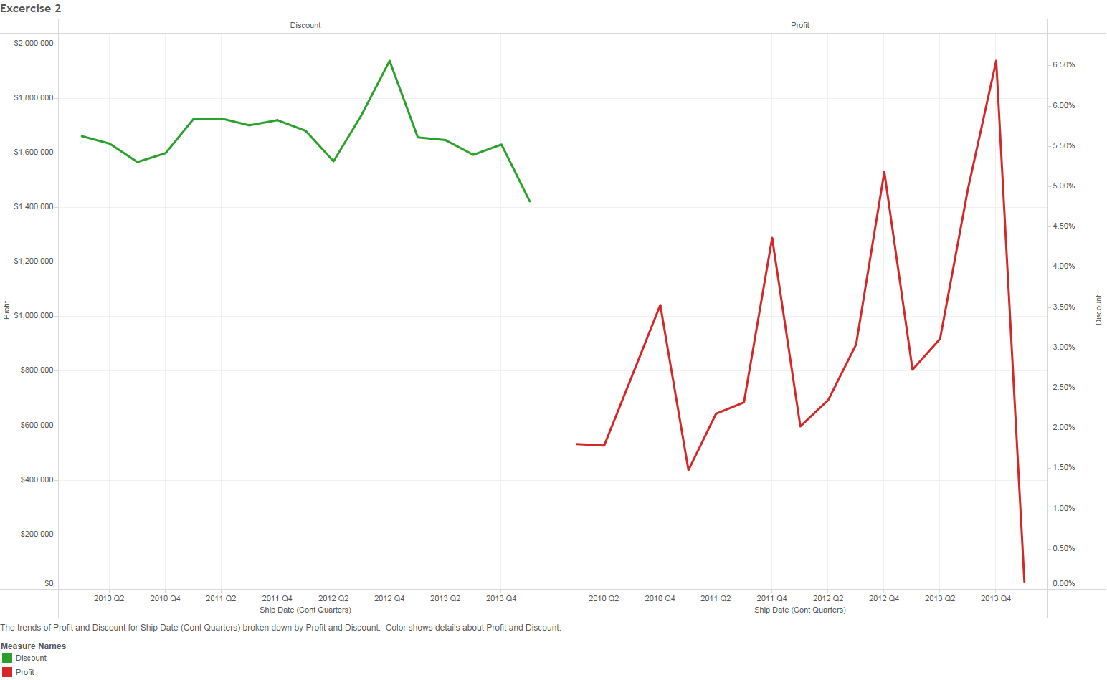

Exercise 3: Develop a horizontal bar graph that:

* is sliced based on firstly Department, and then SubRegion:
* the length of the bars represents the total shipping cost in each SubRegion and Department.
* in each Department, SubRegions are sorted descendingly based on total shipping cost.
* all South SubRegion bars are colored differently.

**Exercise 4**: Produce the following display:

